**C2P2 Forecasting System**

Requirement Specification

1. Data Collection and Storage:

Define the data sources and mechanisms for collecting and storing data.

Ensure data quality and handle missing or erroneous values.

Choose an appropriate database or data storage solution.

1. Data Preprocessing:

Implement data cleaning and preprocessing steps to handle outliers and normalize the data.

Explore feature engineering techniques if needed.

1. Feature Selection:

Analyze the relevance of each feature for the forecasting model.

Consider techniques like correlation analysis to identify relationships among features.

1. Model Selection:

Choose appropriate forecasting models. Common choices include regression models, time series models, or machine learning algorithms like Random Forest, Gradient Boosting, or Neural Networks.

Experiment with different algorithms to find the one that best fits your data.

1. Training and Evaluation:

Split the dataset into training and testing sets.

Implement training routines for the selected model.

Evaluate the model's performance using appropriate metrics such as Mean Squared Error (MSE) or Root Mean Squared Error (RMSE).

1. Hyperparameter Tuning:

Fine-tune model hyperparameters to optimize performance.

Consider techniques like grid search or randomized search.

1. Model Deployment:

Develop a mechanism for deploying the trained model in a production environment.

Choose deployment options such as cloud-based services or on-premises servers.

1. User Interface (Optional):

If applicable, design a user interface for interacting with the forecasting model.

Ensure the interface is user-friendly and provides necessary information.

1. Monitoring and Maintenance:

Implement monitoring tools to track the model's performance over time.

Establish a maintenance plan for updating the model with new data and retraining periodically.

1. Documentation:

Document the entire process, including data sources, preprocessing steps, model selection, and deployment procedures.

Provide clear documentation for the codebase to facilitate collaboration and future development.

1. Security:

Implement security measures to protect sensitive data.

Consider encryption and authentication mechanisms.

1. Scalability:

Design the application to handle an increasing amount of data efficiently.

Ensure that the forecasting model scales appropriately as the dataset grows.

1. Compliance:

Ensure that the application complies with relevant regulations and standards in the domain.

1. Testing:

Develop comprehensive test cases to validate the correctness of the application.

Include unit tests, integration tests, and performance tests.

1. Collaboration and Version Control:

Use version control systems to manage the codebase.

Establish collaboration practices to facilitate teamwork.

**USE CASES:**

Certainly! Use cases help to outline the specific scenarios or interactions that your application should support. Here are some potential use cases for your C2P2 forecasting model application:

1. **Training the Forecasting Model:**
   * **Description:** As a data scientist or engineer, I want to train the forecasting model using historical data on ambient temperature (AT), exhaust vacuum (V), ambient pressure (AP), and relative humidity (RH) to predict power output (PE).
   * **Steps:**
     + Upload historical data.
     + Preprocess the data to handle missing values and outliers.
     + Select features and target variable.
     + Choose the forecasting algorithm.
     + Train the model.
2. **Evaluating Model Performance:**
   * **Description:** As a data scientist, I want to evaluate the performance of the trained forecasting model to ensure its accuracy and reliability.
   * **Steps:**
     + Split the dataset into training and testing sets.
     + Deploy the model on the testing set.
     + Evaluate performance metrics (e.g., Mean Squared Error, Root Mean Squared Error).
     + Adjust model parameters if necessary.
3. **Making Power Output Predictions:**
   * **Description:** As an end-user, I want to input current ambient temperature, exhaust vacuum, ambient pressure, and relative humidity values to receive a prediction of the expected power output.
   * **Steps:**
     + Enter current environmental conditions.
     + Submit the data to the forecasting model.
     + Receive the predicted power output.
4. **Data Visualization:**
   * **Description:** As a user or analyst, I want to visualize historical data and predicted power output to gain insights into trends and patterns.
   * **Steps:**
     + Select the time range for historical data.
     + Generate graphs or charts showing actual vs. predicted power output.
     + Analyze trends and anomalies.
5. **Model Hyperparameter Tuning:**
   * **Description:** As a data scientist, I want to optimize the forecasting model by adjusting hyperparameters for better accuracy.
   * **Steps:**
     + Access the model configuration.
     + Experiment with different hyperparameter values.
     + Evaluate the impact on model performance.
     + Save the optimal configuration.
6. **Deployment to Production:**
   * **Description:** As a system administrator, I want to deploy the trained forecasting model to a production environment for real-time predictions.
   * **Steps:**
     + Package the model for deployment.
     + Integrate the model into the production system.
     + Ensure scalability and reliability.
7. **Monitoring Model Performance:**
   * **Description:** As a system administrator or data scientist, I want to monitor the forecasting model's performance in a production environment to detect potential issues.
   * **Steps:**
     + Set up monitoring tools.
     + Track key performance metrics.
     + Receive alerts for deviations from expected behavior.
     + Investigate and address issues promptly.
8. **Updating the Model with New Data:**
   * **Description:** As a data engineer, I want to update the forecasting model with new data periodically to ensure it remains accurate and relevant.
   * **Steps:**
     + Acquire new data.
     + Preprocess the data.
     + Retrain the model with the updated dataset.
     + Deploy the updated model to production.
9. **User Authentication and Authorization:**
   * **Description:** As an administrator, I want to control access to the forecasting model application and ensure that only authorized users can perform certain actions.
   * **Steps:**
     + Implement user authentication.
     + Define user roles and permissions.
     + Restrict access to sensitive features or data.
10. **Compliance Reporting:**
    * **Description:** As a compliance officer, I want the application to generate reports on model performance and data handling to ensure compliance with relevant regulations.
    * **Steps:**
      + Generate compliance reports on a scheduled basis.
      + Include information on data processing, model accuracy, and security measures.
      + Archive reports for auditing purposes.

**Energy Prediction :**

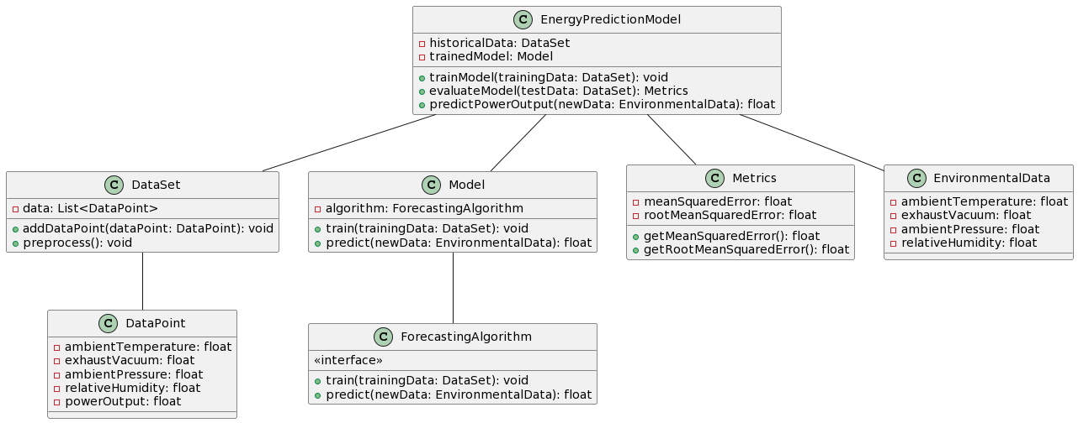

**Data pipeline:**

Certainly! A data pipeline for energy prediction involves several stages, including data preprocessing, modeling, evaluation, handling outliers, and data normalization. Below is a suggested data pipeline that incorporates these stages:

1. **Data Ingestion:**
   * **Description:** Collect data from various sources such as sensors or databases.
   * **Tools/Techniques:** Use ETL (Extract, Transform, Load) processes or tools to ingest data into a central data storage.
2. **Data Cleaning and Preprocessing:**
   * **Description:** Clean and preprocess the raw data to handle missing values, remove duplicates, and address any data quality issues.
   * **Tools/Techniques:** Use tools like pandas in Python or data preprocessing libraries in your chosen programming language.
3. **Outlier Detection and Handling:**
   * **Description:** Identify and handle outliers in the dataset that may adversely affect model performance.
   * **Tools/Techniques:** Statistical methods, visualization tools, or machine learning techniques for outlier detection.
4. **Feature Engineering:**
   * **Description:** Create new features or transform existing ones to enhance the model's ability to capture patterns.
   * **Tools/Techniques:** Use domain knowledge and statistical methods to engineer relevant features.
5. **Data Normalization:**
   * **Description:** Scale numerical features to a standard range to prevent some features from dominating others during model training.
   * **Tools/Techniques:** StandardScaler or Min-Max scaling methods in libraries like scikit-learn.
6. **Data Splitting:**
   * **Description:** Split the dataset into training and testing sets to evaluate model performance on unseen data.
   * **Tools/Techniques:** Use functions like train_test_split in scikit-learn.
7. **Model Training:**
   * **Description:** Train the forecasting model using the preprocessed training data.
   * **Tools/Techniques:** Employ machine learning algorithms such as Random Forest, Gradient Boosting, or Neural Networks.
8. **Model Evaluation:**
   * **Description:** Evaluate the model's performance on the testing set to assess its accuracy and generalization capability.
   * **Tools/Techniques:** Use metrics like Mean Squared Error (MSE) or Root Mean Squared Error (RMSE).
9. **Hyperparameter Tuning:**
   * **Description:** Fine-tune the model's hyperparameters to optimize performance.
   * **Tools/Techniques:** Grid search, randomized search, or Bayesian optimization.
10. **Deployment:**
    * **Description:** Deploy the trained model to a production environment for making real-time predictions.
    * **Tools/Techniques:** Use deployment platforms like Flask for API deployment or containerization tools like Docker.
11. **Monitoring and Maintenance:**
    * **Description:** Implement monitoring to track the model's performance over time and update it as needed.
    * **Tools/Techniques:** Logging, alerting, and periodic retraining based on new data.
12. **Documentation:**
    * **Description:** Document the entire pipeline, including preprocessing steps, model architecture, and evaluation results.
    * **Tools/Techniques:** Use documentation tools like Sphinx or Jupyter Notebooks for inline documentation.

